AE 4361 – Assignment 2

1)

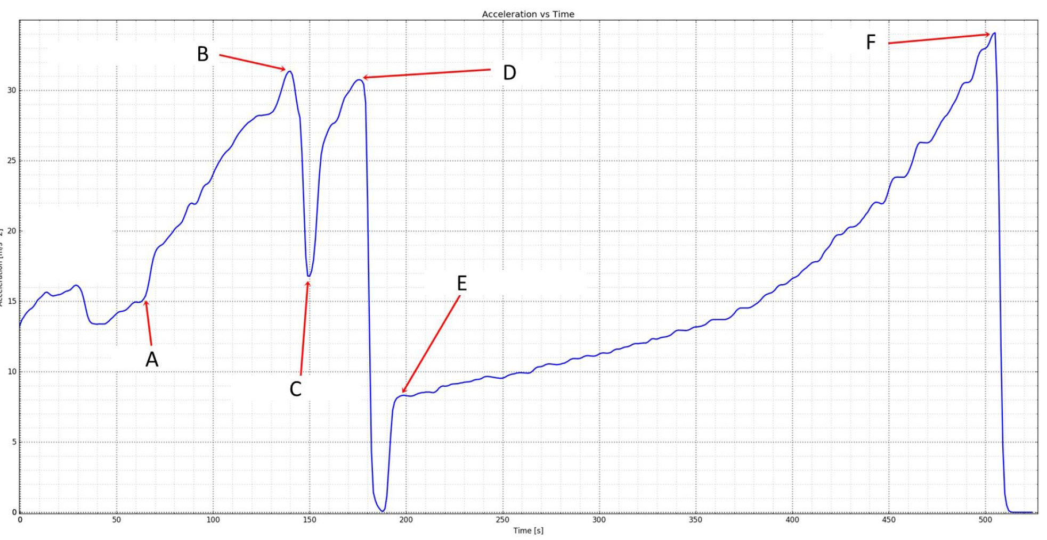

a) Event A occurs at T + 01:10, or at 2:37 in the video. This is the point where max Q is reached, when the rocket experiences the maximum amount of dynamic pressure. Once the rocket has passed that point, it is able to safely increase its acceleration as the atmospheric density is greatly reduced and forces applied on the rocket will always be smaller than at event A. Side boosters throttle back to full power.

b) Event B occurs at T + 02:20, or at approximately 3:55 in the video, where side boosters, which were at full throttle prior start to shut down.

c) Event C occurs at T + 02:30, or at 4:00 in the video, when the side boosters fully power off and detach from the rocket a couple of seconds later. The sharp increase in acceleration is caused by the change in rocket mass due to shedding of the two boosters, as the main stage now only has to carry the payload.

d) Event D occurs at T + 3:00, or at 4:29 in the video, when the payload detached from the Falcon heavy. As it is not attached anymore, the payload has no acceleration at this time.

e) Even E occurs at T + 3:15, or at 4:45 in the video, the main engine cuts off and the payload engine starts up, allowing the payload to start accelerating once again.

f) Event F occurs at T + 8:25, or at 10:00 in the video is the second stage engine cutoff. The payload has now completed its journey to a specified parking orbit and may or may now reaccelerate in the future to reach a desired orbit.

2) a)

|  |  |  |  |  |
| --- | --- | --- | --- | --- |
| **Vehicle** | **Number of stages** | **Fairing diameter (m)** | **Propellant type** | |
| Falcon 9 (Full thrust, RTLS) [1] | 2 | 5.2 | *Stage I* | Liquid |
| *Stage II* | Liquid |
| Antares (231)  [2] | 3 | 3.9 | *Stage I* | Liquid |
| *Stage II* | Solid |
| *Stage III* | Liquid (monoprop) |
| Pegasus (XL w/ HAPS)  [3] | 4 | 1.27 | *Stage I* | Solid |
| *Stage II* | Solid |
| *Stage III* | Solid |
| *Stage IV* | Liquid (Hydrazine) |
| Atlas V (401)  [4] | 2 | 4.2 | *Stage I* | Liquid |
| *Stage II* | Liquid |
| Atlas V (501)  [4] | 2 | 5.4 | *Stage I* | Liquid |
| *Stage II* | Liquid |

Propellant types found at:

[1] “SpaceX – Falcon 9,” SpaceX, Accessed 29 January 2022. <https://www.spacex.com/vehicles/falcon-9/>

[2] “Antares User’s guide,” Northrop Grumman, September 2020, Accessed 29 January 2022. <https://www.northropgrumman.com/space/antares-rocket/>

[3] “Pegasus Payload User’s guide,” Northrop Grumman, September 2020, Accessed 29 January 2022. <https://www.northropgrumman.com/space/pegasus-rocket/>

[4] “Atlas V,” ULA Launch, 2019, Accessed 29 January 2022. <https://www.ulalaunch.com/rockets/atlas-v>

b)

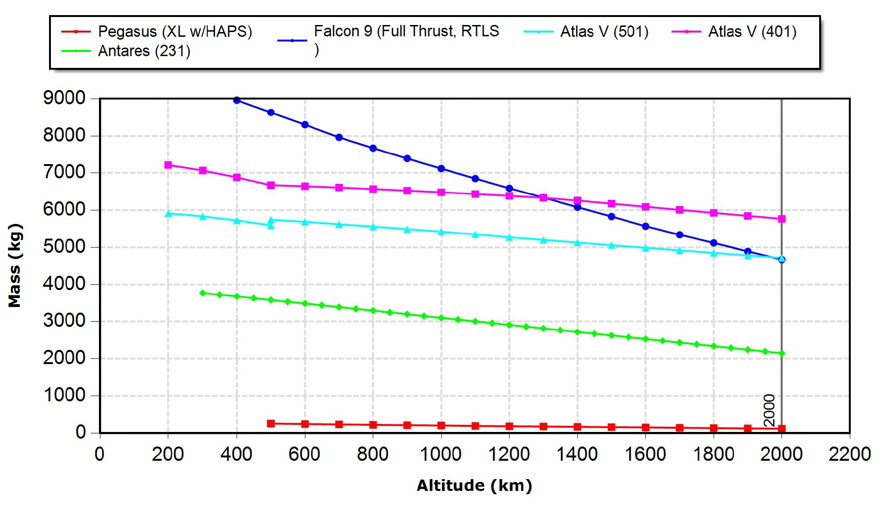

Noe Lepez Da Silva Duarte

**Figure 1.** Altitude vs amyloid mass for each launch vehicle

**Table I**. Table of payload capabilities for each launch option

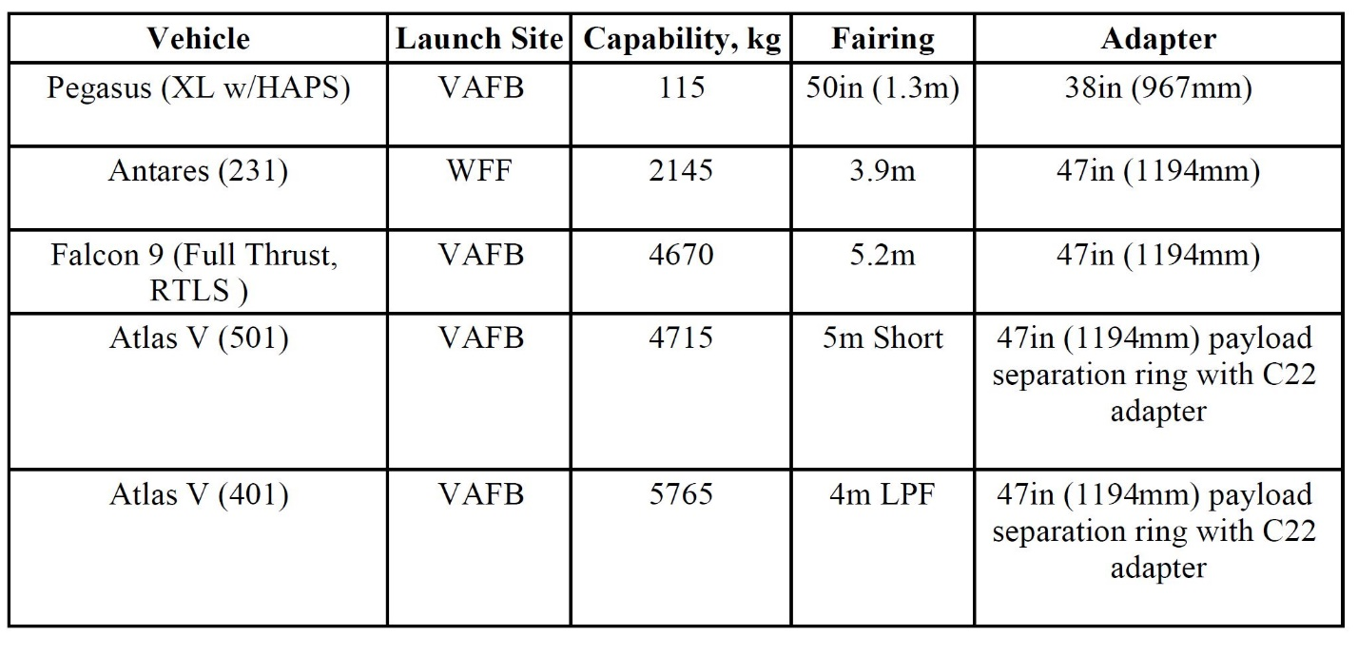

Noe Lepez Da Silva Duarte

c)

|  |  |  |
| --- | --- | --- |
| **Vehicle** | **Able to satisfy requirements** | **Cost ($)** |
| Falcon 9 (Full thrust, RTLS) | Yes | 10,800,000 |
|
| Antares (231) | No | - |
|
|
| Pegasus (XL w/ HAPS) | No | - |
|
|
|
| Atlas V (401) | No | - |
|
| Atlas V (501) | No | - |
|

While Atlas V could carry the payload, unlike the Antares and Pegasus rockets, its minimum park orbit perigee is of 180km, more than the 170km required. Only SpaceX’s Falcon 9 could carry out the mission, with its 160km minimum park orbit perigee. The launch would cost $10.8 million.

d)

|  |  |  |
| --- | --- | --- |
| **Vehicle** | **Able to satisfy requirements** | **Cost ($)** |
| Falcon 9 (Full thrust, RTLS) | No | - |
|
| Antares (231) | No | - |
|
|
| Pegasus (XL w/ HAPS) | No | - |
|
|
|
| Atlas V (401) | No | - |
|
| Atlas V (501) | Yes | 36,000,000 |
|

Only the Atlas V (501) rocket has a fairing diameter large enough to accommodate the satellite with a diameter of 5.4m. The launch would cost $36 million.

3) a)

b)

c) 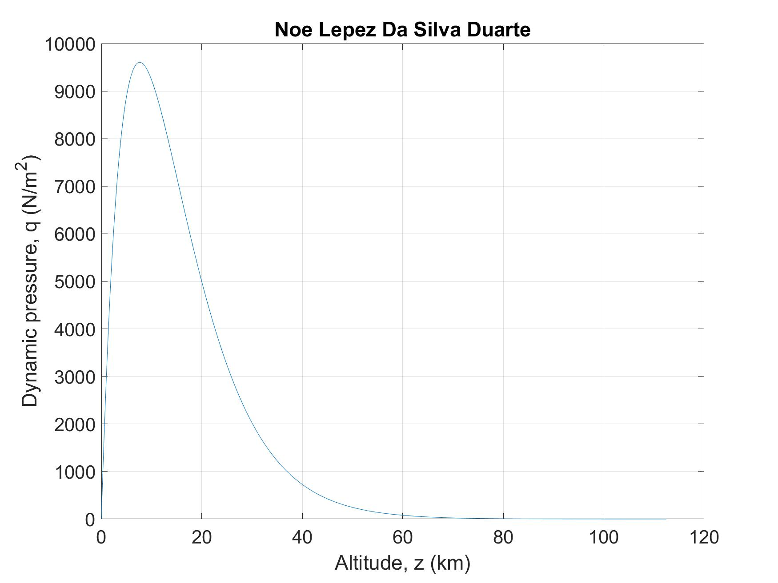

**Figure 2.** Plot of altitude vs. dynamic pressure for the scenario given in question 3 part c)

d)

Maximum dynamic pressure: 9605 N/m2

At altitude: 7642m

At time: 78s

e)

*Falcon 9*:

$$A=π×{\left(\frac{5.2}{2}\right)}^{2}=21.24m^{2}$$

$$F_{qmax}=9605×21.24=203977N$$

*Falcon Heavy:*

$A_{booster}=π×{\left(\frac{3.7}{2}\right)}^{2}=10.75m^{2}$

$$F_{qmax}=9605×21.24+2×9605 ×10.75=203977+2×103274=410525N$$